European drought of summer 2022

David Fairbairn (ECMWF), Patricia de Rosnay (ECMWF), Silvia Puca (H SAF, Protezione Civile/Italian Civil Protection Department, Presidency of the Council of Ministers), Luca Brocca (CNR-IRPI/ National Research Council of Italy, Research Institute for Geo-Hydrological Protection), Sebastian Hahn (Tu Wien)

Abstract
In the summer of 2022, droughts and heatwaves affected many parts of Europe, leading to high temperatures, forest fires and crop failures. The drought conditions were caused by a lack of precipitation and above average temperatures. The drought conditions were monitored by the H SAF precipitation and soil moisture products. The comparison of the near-real-time products with long-term data records demonstrated the exceptional severity and extent of the drought over Europe.

Summary
H SAF precipitation and soil moisture products capture drought conditions over Europe during the summer of 2022

Description
High pressure dominated much of Europe during the period, bringing with it drier than usual conditions.

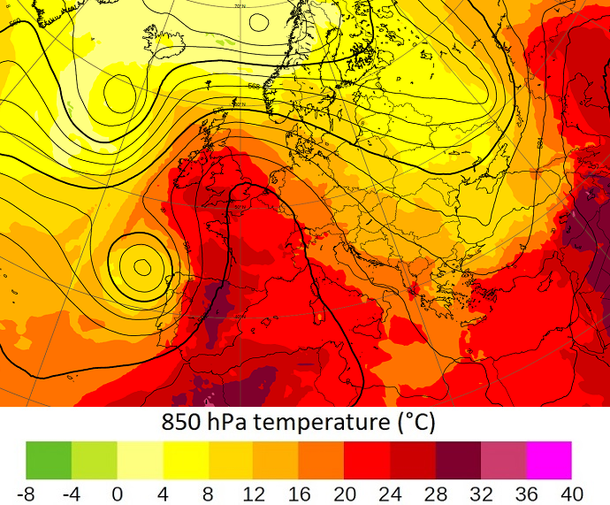
Figure 1 36-hour 850hPa air temperature forecast from ECMWF, 18th July 2022, 00 UTC
Figure 1 shows the ECMWF 850hPa 36-hour air temperature forecast on 18th July 00 UTC, showing an exceptionally warm air mass being advected from Africa up to the British Isles (URL: https://www.ecmwf.int/en/about/media-centre/focus/2022/update-european-heatwave-july-2022, last accessed September 2022). In England, the 850hPa temperatures exceeded 20C in many areas on 19th July, with much higher temperatures near the surface. A record high 2 m temperature of 40.3C was recorded at Coninigsby, UK (URL: https://www.metoffice.gov.uk/about-us/press-office/news/weather-and-climate/2022/record-high-temperatures-verified, last accessed September 2022).

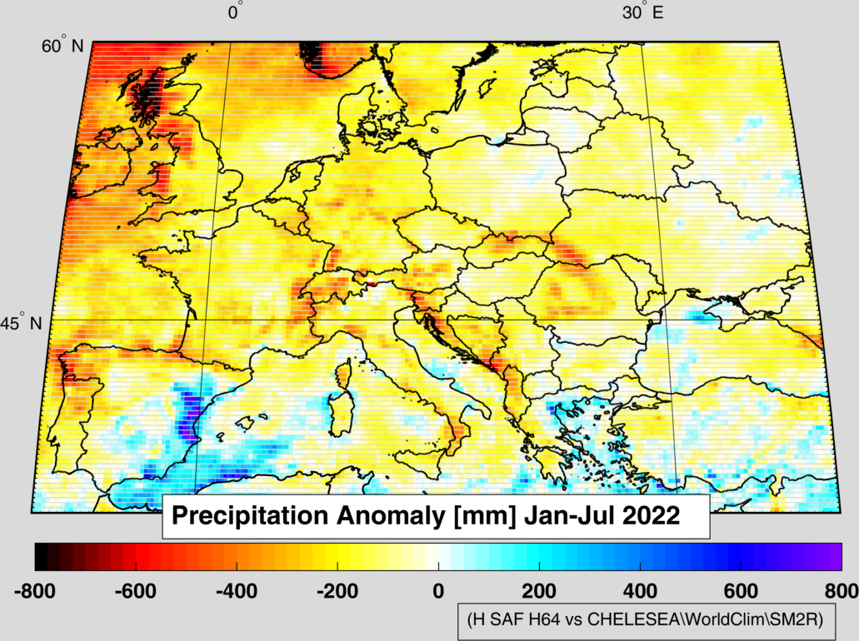
Figure 2 Precipitation anomaly in Europe from January to July 2022 by using H SAF H64 and long-term climatology from CHELSEA\Worldclim (https://doi.org/10.5281/zenodo.1435912)
Figure 2 shows the precipitation anomaly in Europe from January to July 2022 by using H SAF H64 and the long-term climatology from CHELSEA/Worldclim. Negative precipitation anomalies are present over most of Europe, which lead to drier than normal soil moisture conditions. Dry soil moisture conditions are associated with low evaporative cooling from the soil and low transpiration cooling from vegetation. This contributed to the exceptionally high temperatures, forest fires and crop failures that were experienced in Europe during the summer of 2022.
Figure 3 shows the ASCAT Surface Soil Moisture (SSM) anomaly (deviation from climatology) based on the latest ASCAT SSM Data Record product (v7). Strong dry anomalies (deviation < -10%) are present over many parts of Europe. The Copernicus Global Land Service (CGLS) Soil Water Index 10-daily SWI 12.5km V3 (SWI10) product is shown in Figure 4, which takes H SAF ASCAT NRT SSM products as input. The SWI10 anomalies for July 2022 shows also dry conditions in deeper soil layers. A ranking of the SWI10 anomaly based on the past 16 years (2007-2022) is given in Figure 5. A ranking of 1 (16) indicates the driest (wettest) July during the period. Several parts of Europe were ranked as 1, highlighting the severity and extent of the drought. This is even more remarkable given that several dry European summers were recorded during the 16-year ranking period (e.g. 2015, 2018, 2019).
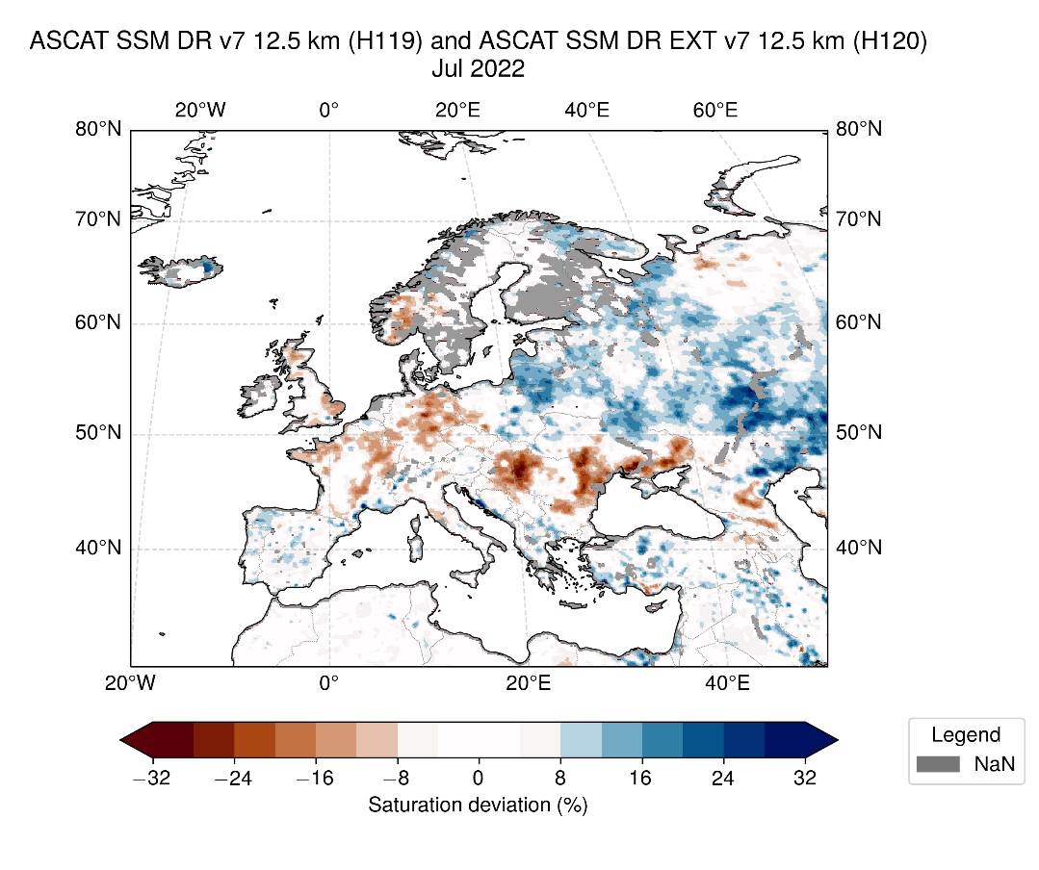
Figure 3 Surface soil moisture deviation from Climatology (2007-2021) for July 2022 from the H SAF H119 and H120 ASCATSSM data record products (http://dx.doi.org/10.15770/EUM_SAF_H_0009)

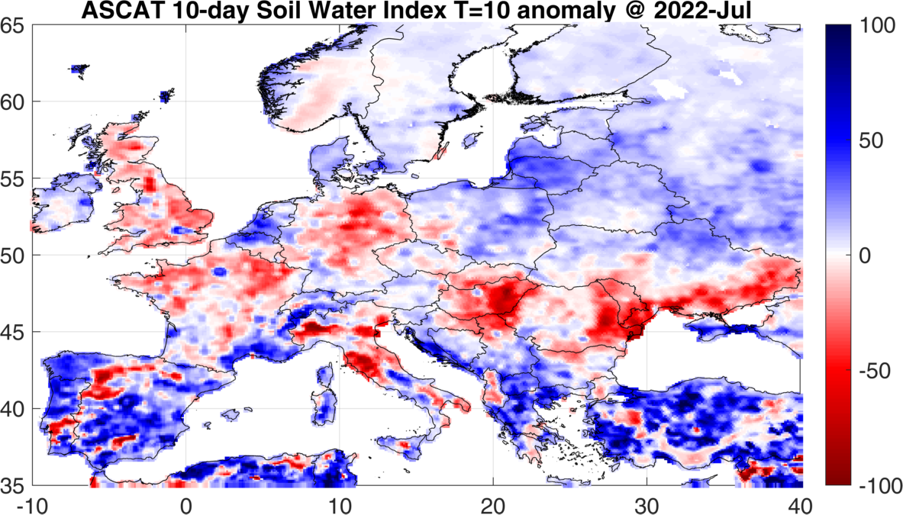
Figure 4 Copernicus Global Land Service (CGLS) Soil Water Index 10-daily SWI 12.5km V3 (SWI10) anomaly for July 2022.
The deeper soil moisture layers are affected during sustained dry periods, leading to crop failures and forest fires. An animation of the H SAF root-zone soil wetness index anomaly (expressed as a percentage of saturation) for layer 3 (28-100 cm depth) from 1st to 31st July 2022 is shown in Figure 6.

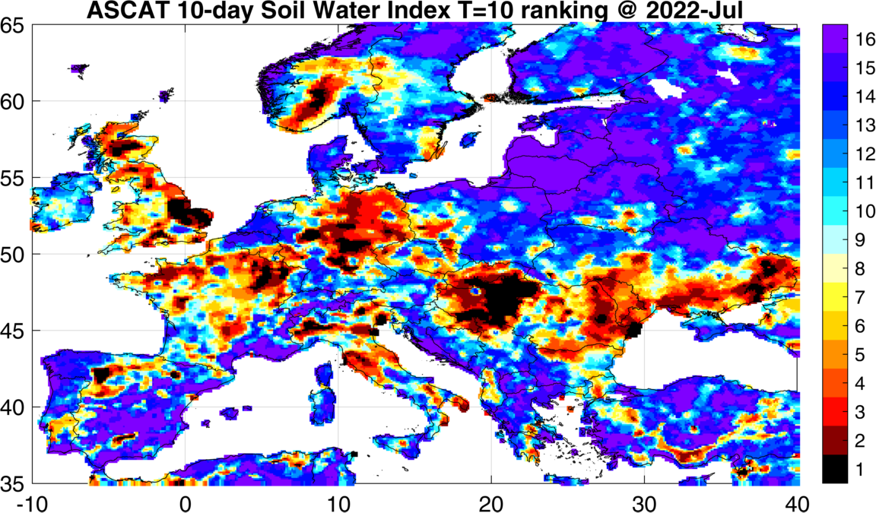
Figure 5 Copernicus Global Land Service (CGLS) Soil Water Index 10-daily SWI 12.5km V3 (SWI10) product. A ranking of 1 (16) corresponds to the driest (wettest) July during the 16 year period.

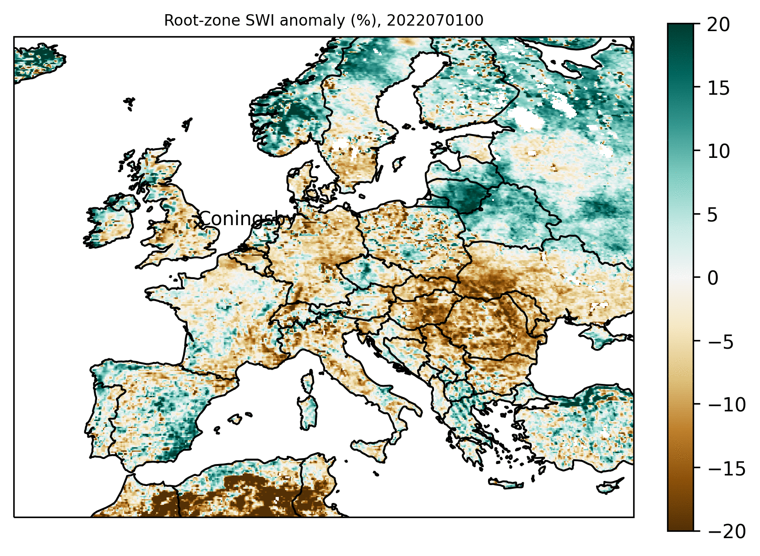
Figure 6 RZSM-ASCAT-NRT-10km (H26) soil moisture anomaly (expressed as a percentage of saturation) over the period 20220701 to 20220731, 00 UTC, for the third H SAF root zone layer (28-100 cm depth) with respect to 1992-2021 data record (H141/H142) July mean
It is based on the comparison of the near-real-time soil moisture product (H26) with the climatological data record and extension (H141/H142, 1992-2021). Anomalously dry conditions developed in the root-zone over many parts of Europe.

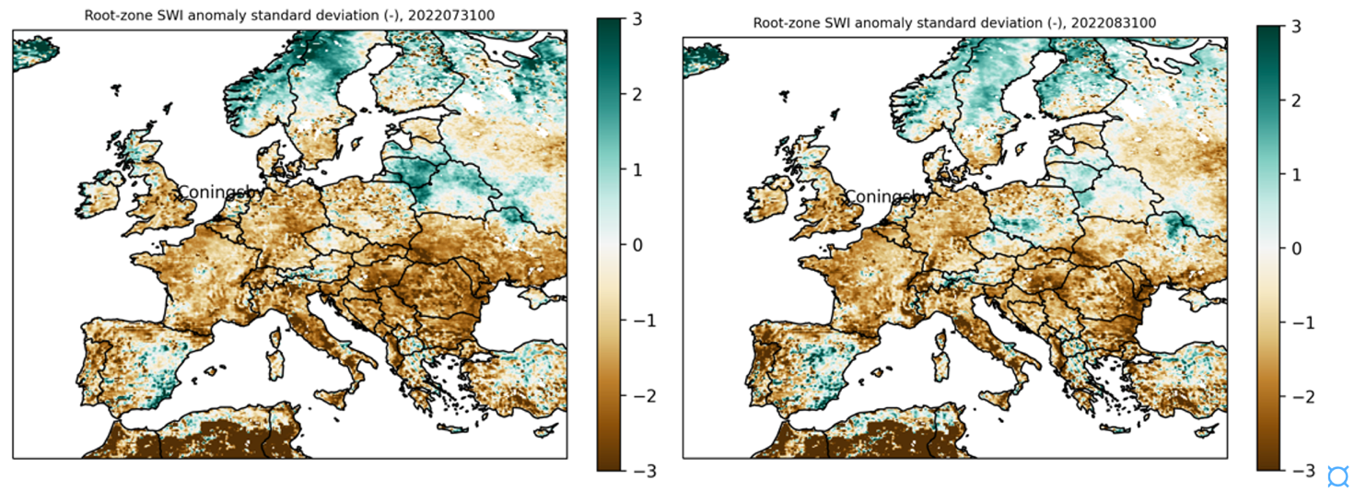
Figure 7 Left: RZSM-ASCAT-NRT-10km (H26) root-zone (28-100 cm depth) soil moisture anomaly for 20220731, expressed as standard deviations from the July mean. Right: RZSM-ASCAT-NRT-10km (H26) root-zone soil moisture anomaly for 20220831, expressed as standard deviations from the August mean

The plots in Figure 7 for 31st July (left) and 31st August (right) show the same variable as Figure 6 except that the anomaly is divided by the data record standard deviations for the months of July and August respectively. Figure 7 demonstrates unusually dry conditions of -1 to -3 standard deviations below the mean at the end of July (left) and the end of August (right).

